Cooling Pits
Q. Why do we need them
A. A cooling pit is required to be installed where a liquid trade waste discharge is likely to exceed 38˚C this temperature is consistent across all authorities. This is so the water can cool to the legally acceptable temperature before being discharged to the authority sewer system.
Incoming hot waste is cooled down by mixing with wastewater already within the pit until the temperature reaches the authority acceptable temperature.
It should be noted that this authority temperature requirement of 38˚C is at the point of discharge to the authority main (generally, the boundary trap).
Additionally, the acceptable temperature for installation for sanitary plumbing and drainage pipework installed in uPVC pipework is 60˚C and that for trade waste drainage HDPE should be utilized for discharge temperatures above this point.
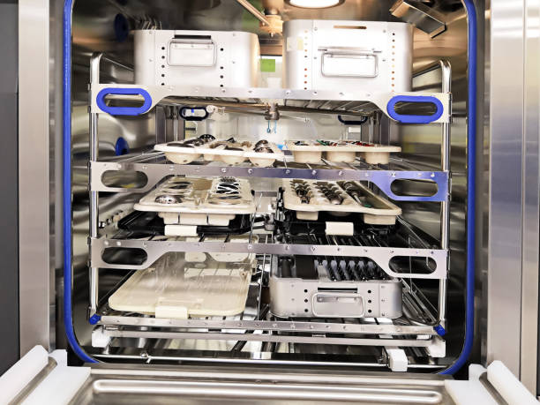
Q. Applications
A. Commercial laundries
Laundromats
Aged care facilities / Nursing Homes
Hospitals – CSSD Units
Hotels

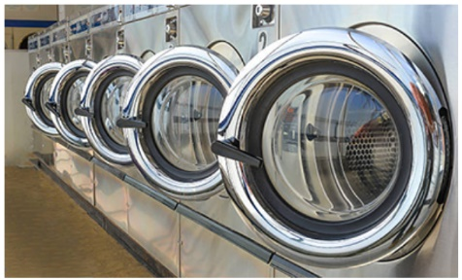
A cooling pit is not required if only cold water is used for washing, or a device reducing the temperature of hot water is installed. Similarly, the requirement for a cooling pit does not apply to laundries that use ozone technology in all washing machines in the premises. Cold water is mostly used in this process.

Q. What Size Cooling Pit will be required
A. The capacity of the pit should be sufficient to allow the temperature to drop to the authority stipulated temperature for discharge, and can be determined by the following formula:
The calculations regarding the capacity of the cooling pit must be submitted with the liquid
trade waste application.

CALCULATIONS FOR COOLING PIT SIZE
V = VH + (VH x F)
F = TH - TA / TA - TC
Where:
V = minimum volume of the pit below the water level
VH = estimated maximum volume of hot water discharged at one time
F = the estimated factor
TH = maximum temperature of hot water discharged into the pit
TC = assumed temperature of cold water in the pit, say 20°C
TA = temperature of waste allowed into the sewer, say 38°C.

Example:
Information of discharge volume and temperature of hot water – note project information should be sourced from equipment manufactures
VH = 0.552 kL
TH = 80 degrees C
TC = 20 degrees C
TA = 38 degrees C
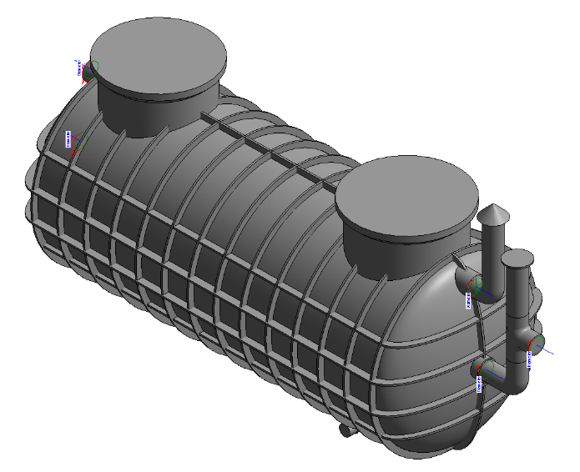
Therefore F = 80 - 38 / 38 - 20
= 42 / 18
= 2.33

So
V (kL) = 0.55 + (0.55 x 2.33)
= 0.55 + 1.28
= 1.83 kL needs to be below the water level of the cooling pit

Halgan Pit suitable for above example
- HCPS2000 – Halgan Polyethylene Cooling Pit

Halgan Cooling Pits – “HCP……”
Halgan manufacture cooling pits from 300 litres through to 10000 litre capacity with a range of above and below ground models to suit project specific requirements.
Additionally for commercial laundries and those within Aged Care Developments we can provide a removable straining basket to trap lint, hair and other fibrous matter before the wastewater enters the cooling pit this model is Halgan “HLT….” In similar size range
Please contact Halgan sales to discuss you cooling pit requirements.
Example Standard Drawings – HCP -Cooling Pit & Halgan Lint Trap

